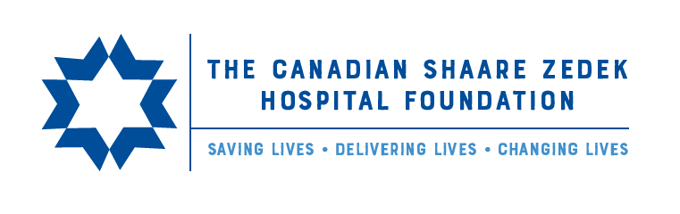

Shaare Zedek Mission to Israel
March 31 – April 4, 2024

TERMS AND CONDITIONS

Shaare Zedek’s Mission to Israel starts in Israel on Sunday, March 31, 2024, and concludes on Thursday, April 4, 2024.

$2,728 CAD per person (does not include International Airfare)
The price is based on the following:
- Minimum 25-29 participants: Maximum of 30 participants

The mission includes the following:
- Licensed, English speaking tour guide, traveling with the group at all times
- 4-nights’ accommodation at the prestigious Inbal Hotel Jerusalem
- Breakfast and lunch
- Welcome dinner
- Luxury air conditioned/heated bus
- BBQ dinner with IDF soldiers
- Armed guard traveling with the group at all times
- Planned and exclusive itinerary
- All entrance fees, activities, speakers, and site visits (as per itinerary) unless stated otherwise
- Additional dinner
- Medical insurance

Not included:
- International Airfare
- Travel insurance
- Gratuities for guide, driver, field coordinator
- VAT for Israeli citizens traveling as members of delegation
- Donations or speakers’ fees
- Pre and post trip accommodations
- 2 Dinners
- Hotel upgrades

Payment schedule
** Registration form and $500.00 CAD deposit due by March 8th, 2o24
** Full payment of $2,728.00 CAD (deposit deducted) due by March 19th, 2024

Single supplement is $878.00 CAD for 4 nights

How to make a payment
Please contact one of the following to make a payment:

The Canadian Shaare Zedek Hospital Foundation: (416)-781-3584

Rafi Yablonsky: (647)-449-6342
Ryablonsky@hospitalwithaheart.ca

Rochelle Tessler: (416)-986-6772
Rtessler@hospitalwithaheart.ca

Cancellation Fees:
All cancellations must be made in writing to Rtessler@hospitalwithaheart.ca Cancellation terms will be applied based on the date that the written cancellation is received.

Upon receipt of cancellation, registration deposit is non-refundable, or it can convert to a donation with a full tax receipt.

1) Cancellation of the Entire Mission by Shaare Zedek
In this situation, all participants will receive a full refund including deposit and payment.

2 ) Cancellation of individual participants
In situations where one or more participants cancel, but the mission itself is not cancelled, the cancellation fee will depend on the date of the written cancellation. Individual cancellations are to be made by March 25th.

General Notes
- If you arrive in Israel prior to the Shaare Zedek Mission to Israel start date, you are responsible to meet the group at the Inbal Hotel on March 31st
- Current travel policies require that each participant has health insurance

Travel documents
- We recommend you carry copies of your travel documents
- We are not responsible for your passport or individual belongings
- Ensure that your documents are valid

